DBMS Lab: SQL Joins and Transactions
Use the following tables:
- Employees
- Departments
- Projects
- Customers
- Orders
- Products
- Order_Details
DML Operations:
- Insert a new employee into the Employees table.
- Update the salary of employees working in the CSE department by 10%.
- Delete employees whose salary is below ₹30,000.
- Display all employee details.
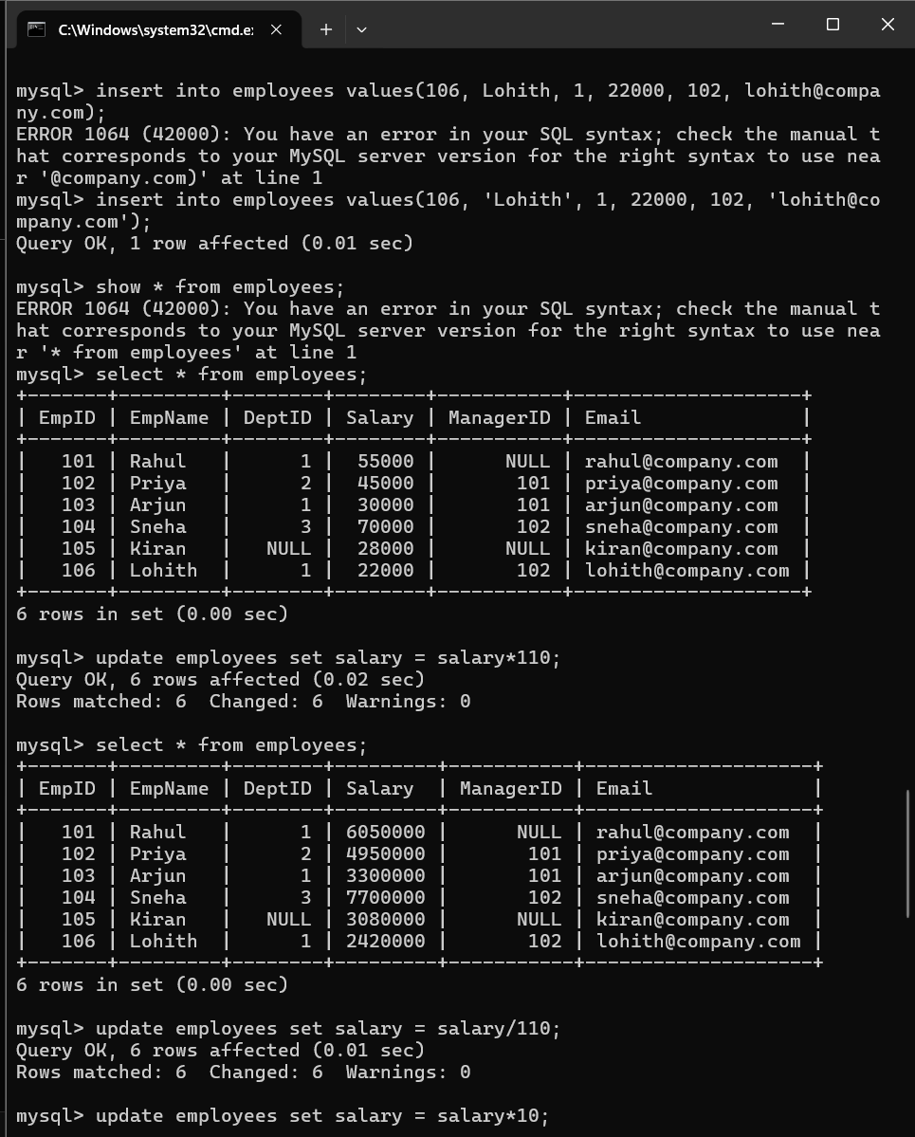
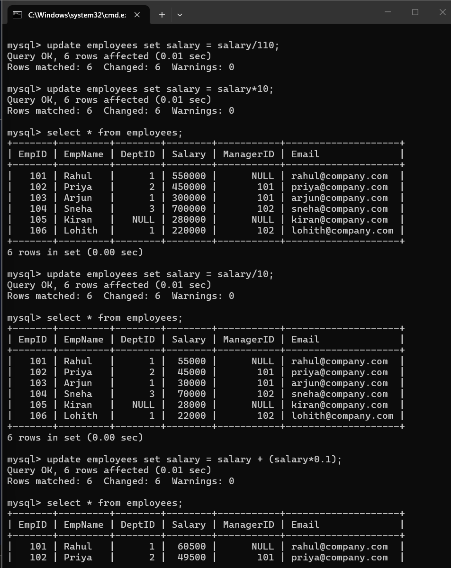
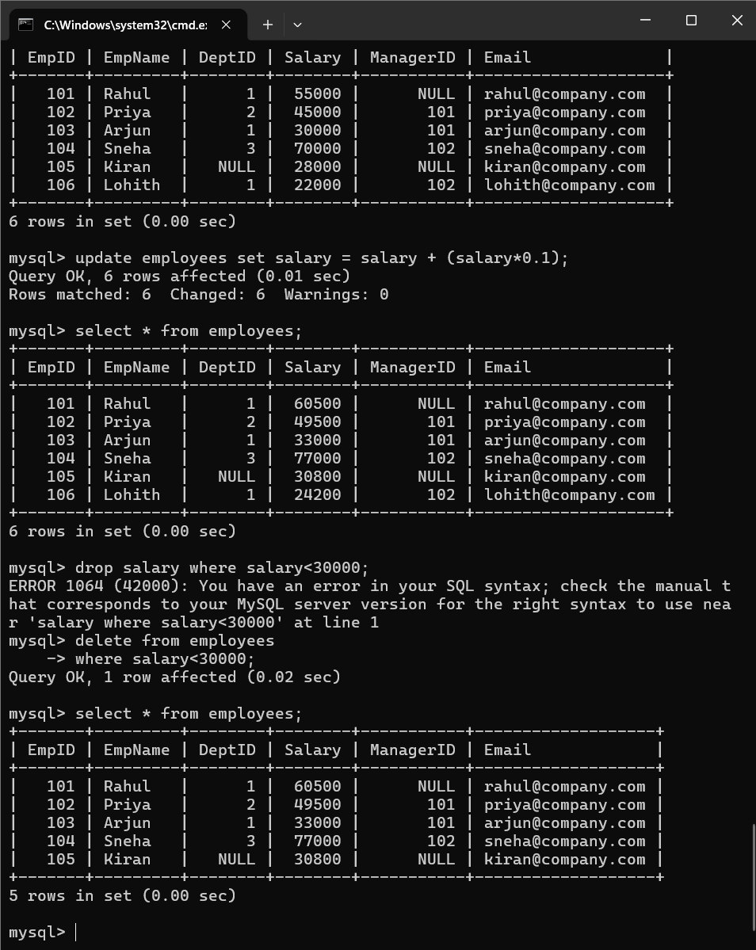
JOIN Queries:
- Display employee names along with department names.
- Display employees who do not belong to any department.
- Display all departments even if they have no employees.
- Display employee and manager names using SELF JOIN.
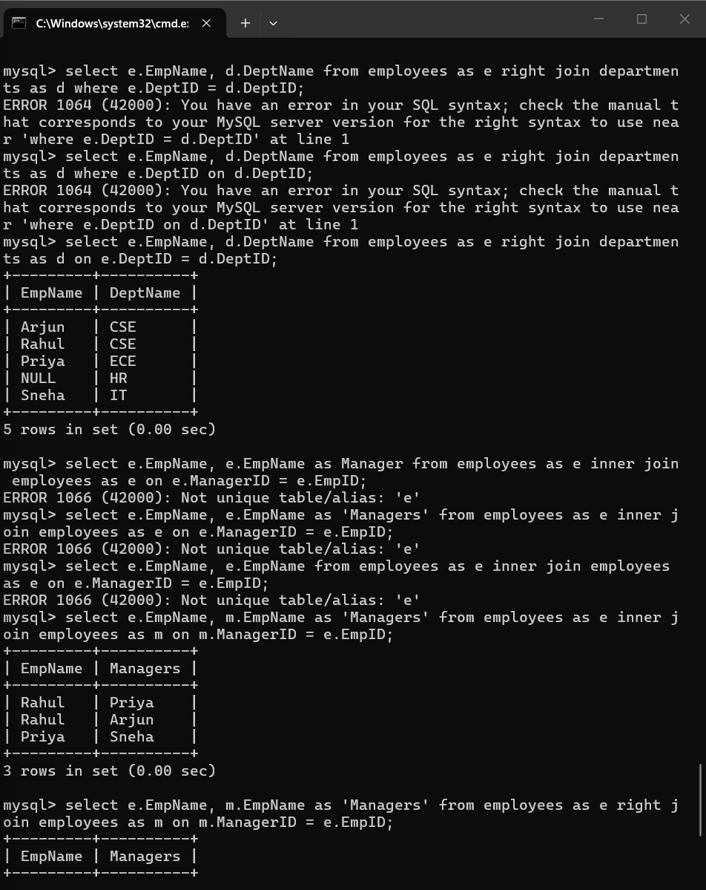
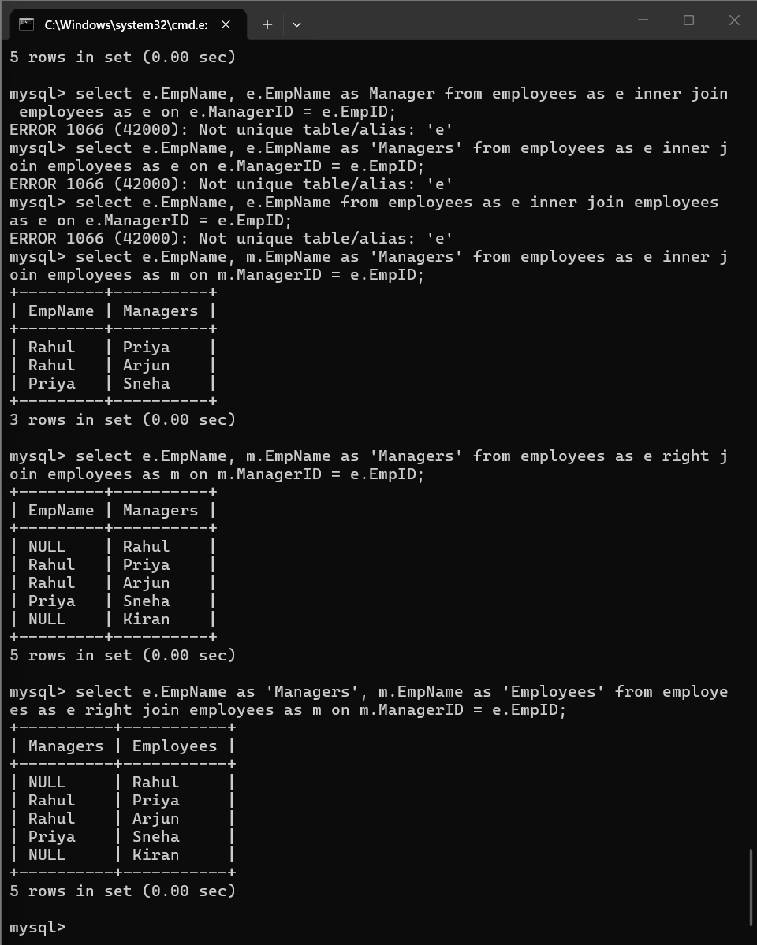
Aggregate Functions:
- Find the total number of employees.
- Find department-wise average salary.
- Display departments where average salary exceeds ₹60,000.
- Display the highest and lowest salary.
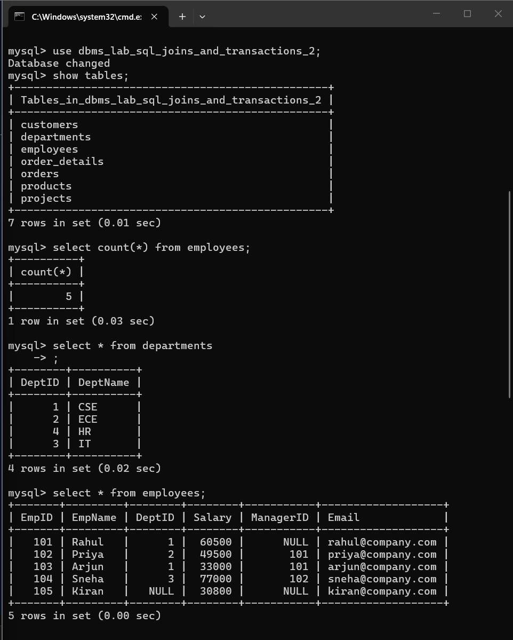
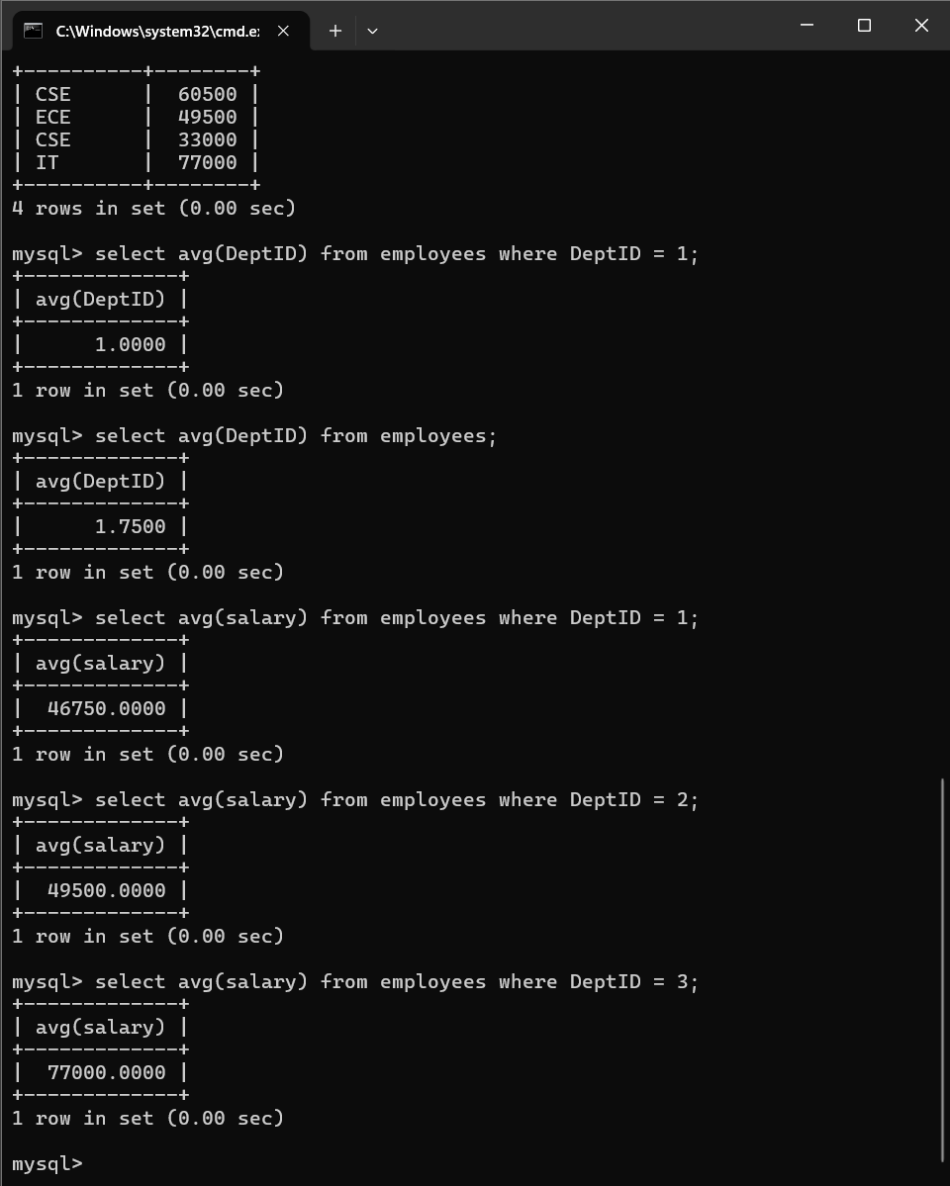
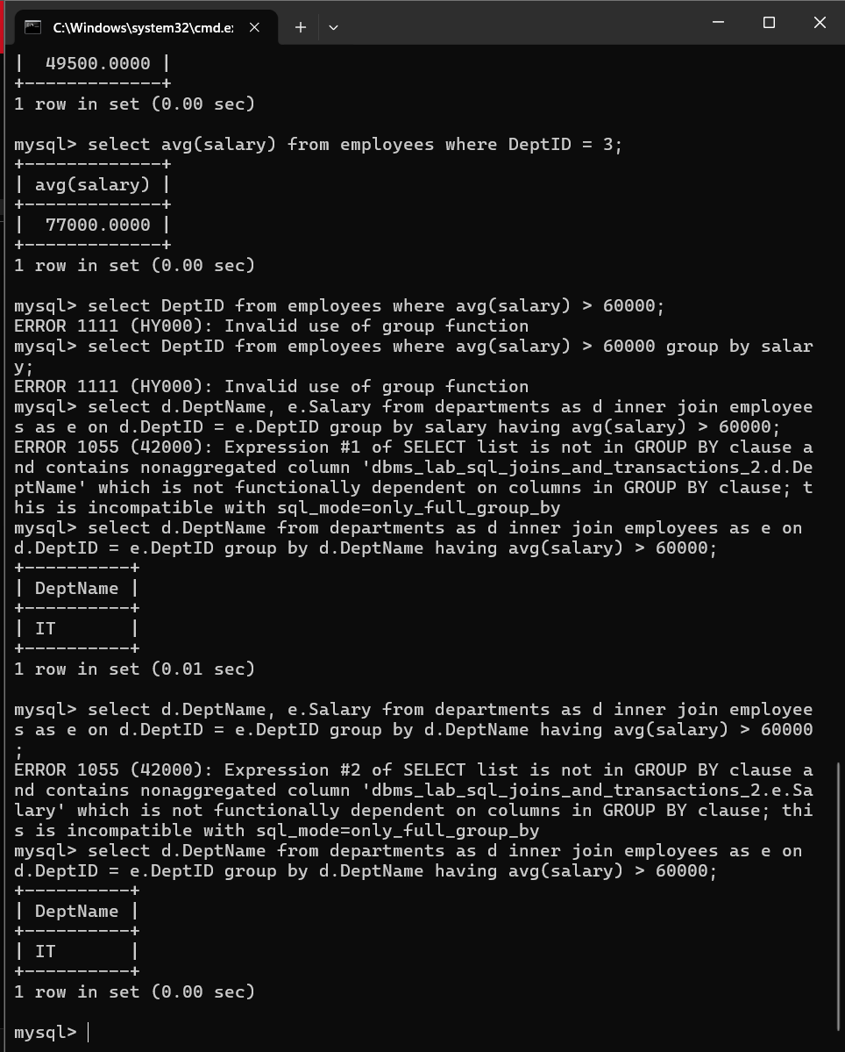
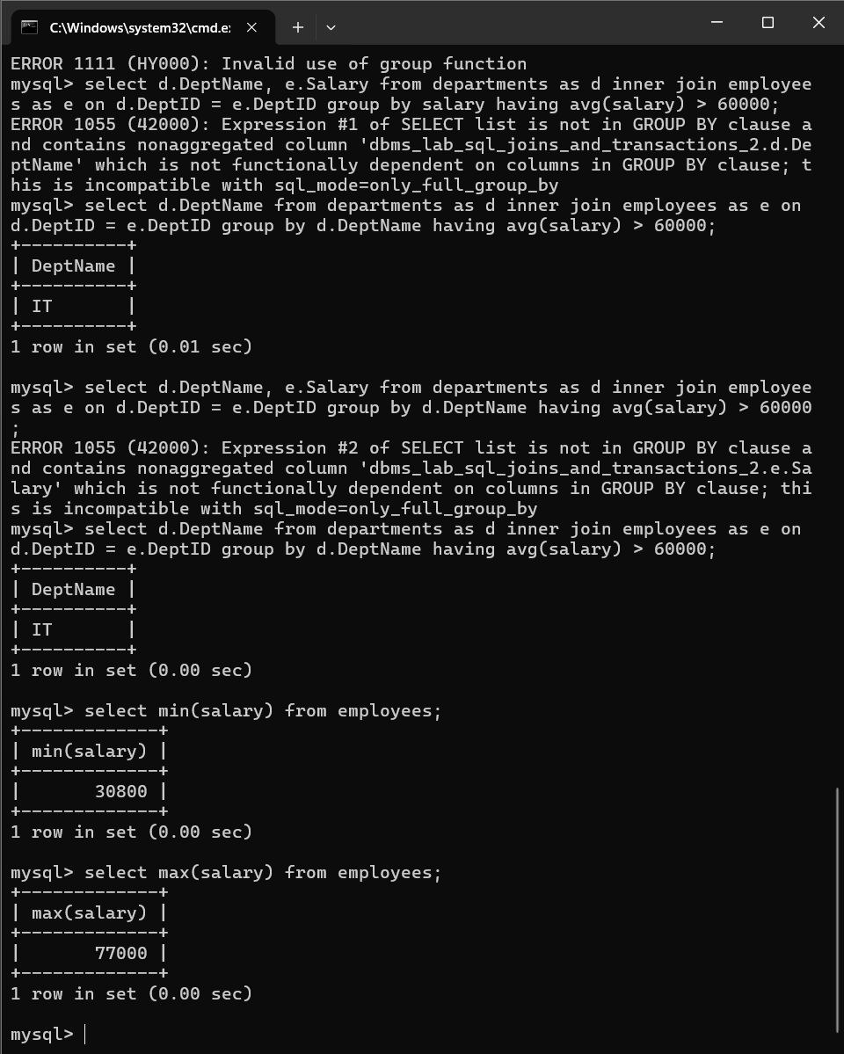
Subqueries:
- Display employees earning more than the average salary.
- Find employees working in the same department as Rahul.
- Display the employee receiving the highest salary.
- Display departments having more than five employees.
- Find the second-highest salary using a window function.
- Display employees earning above their department's average salary.
- Find customers who have never placed an order.
- Display the top-selling product.
- Find departments with the maximum number of employees.
- Display monthly sales using window functions.
- Rank customers based on total purchase amount.
- Display employees whose salary is greater than their manager's salary.
- Find duplicate email addresses using GROUP BY and HAVING.
